We are absolutely thrilled you are interested to join us at Rohlik Group. By now we have spoken to you about your experience and personality in great detail. Next step is to find out how you tackle a task in reality.

**Group Recruitment Lead**

**Task 1**How would you project values/culture code into a career site, job adds & interview process?

**Task 2**You have received information of a new launch in Poland set for Q 2025.   
How would you approach hiring the leadership team to meet the launch date timeline?

**Additional Information**

* Culture code & Values info below

**Format**

We are not strictly set on the form of the presentation. Whatever works for you and you are comfortable with, works for us. So if you just want to have an open forum discussion without any materials, we are in. If you want to present any documents to us, we will provide the tools for it or bring your own. Just let us know.

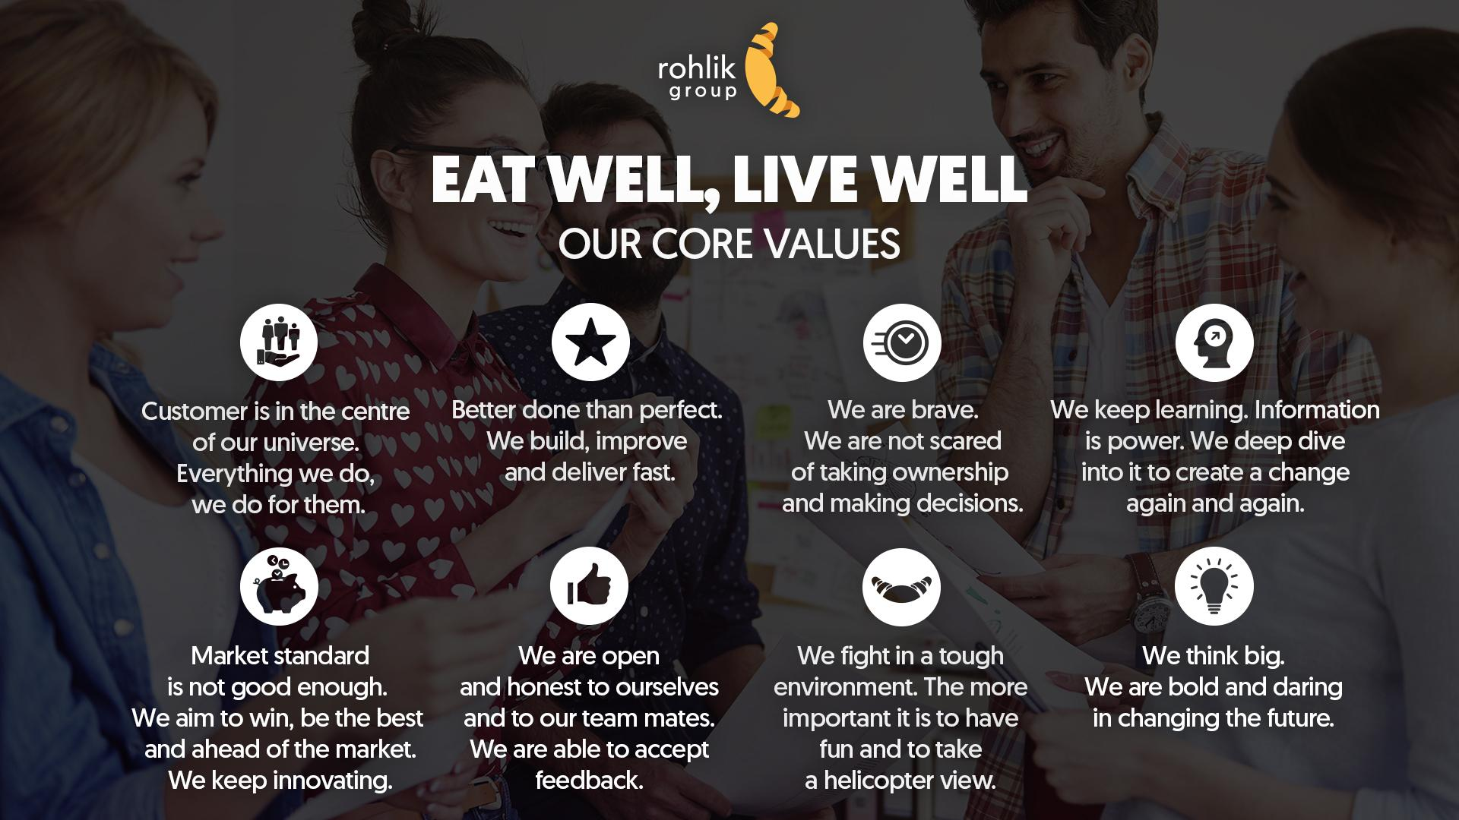

**Rohlik Culture Code**

**Our mission**

Our goal in life is to make other peoples’ lives better. We do it by delivering quality groceries in a

fast and convenient manner. We want to gradually change the way people buy groceries, so

that they enjoy healthier and happier lives, spending more time doing what they love rather than

waiting in traffic and supermarket queues.

We fully realize that changing the old habit of going to a grocery store is not an easy feat. That’s

why we believe that what we build at Rohlik must not just be better than the traditional way of

shopping, but ten times better…

**Life at Rohlik**

Building such a life-changing business is not for everyone. Such a mission is difficult. Life at

Rohlik is difficult.

We find our entrepreneurial culture to be both exciting and challenging, because we are never

stuck maintaining an existing product, but are instead focused on developing new product ideas

and strategies.

Rather than agreeing with each other to make our lives easier, we often disagree to be better

and make our customers’ lives easier.

We like to be quick. We have a big mission ahead of us and we need to move fast to succeed.

There is no time for long e-mails, long presentations, long monologues. Sometimes there is no

time for pleasantries. Get. To. The. Point. And get stuff done.

We are doing something that has never been done before in the grocery business. Clearly we

rarely succeed at the first shot. We fail more often creating new things that we were used to in

our previous lives, but that’s ok.

**Continuous Improvement**

We didn’t join Rohlik to make our lives more comfortable. Changing what people think and how

they shop is difficult. It’s a somewhat painful process for our customers and it’s also painful for

us. Sometimes it hurts to step out of the comfort zone. We do it anyway, because we know it

helps us have stronger ideas and move forward faster.

We like to weigh different ideas: sometimes we go ahead and try, sometimes we adjust and

make it better, sometimes we park it for later, sometimes we kill it completely. The intention is

always to make Rohlik better. Having your idea or your area challenged often feels personal.

But remember, this is not about our ego, this is about making our customers’ lives better.

Best way to get better is to admit our mistakes, provide and accept feedback and adjust

accordingly. To err is human. We need people who are not afraid of making mistakes, but then

also don’t shy away from facing the truth.

**Who we hire**

People who work at Rohlik are independent thinkers with an opinion. We are not afraid of saying

what we think is right for our customers or for the business.

Rohlik people are passionate about helping our customers live healthier and happier lives. We

want this to happen and we want it quickly.We hire people who want to change the world and are ready to take up difficult tasks with some tripping over.

Rohlik people don’t wait to be told what to do but themselves propose new ways to get better.

We hire people who want to spend their lives at work this way. We have a versatile mix. Both

young and older, both junior and senior experienced colleagues.

**Your Personal Rohlikness Check**

This little checklist is made for you. It may be hard to imagine what life with Rohlik will be like.

These eight questions help you see for yourself if you would like it or not. Please, answer the

questions truthfully. If you don’t, it will only make your life miserable in the future. We don’t want

that.

Customer Obsession

Customer is in the centre of our universe. Everything we do, we do for them.

❏ I believe that the Customer must always benefit from what I do

❏ I take extraordinary effort to satisfy the Customer

❏ I am able to see things from the Customer point of view

Speed

Better done than perfect. We build, improve and deliver fast.

❏ I am able to work with incomplete data set

❏ I am able to take risk and move fast

❏ I am able to identify an opportunity without detailed info at hand

❏ When I don’t know the answer, I will find someone who does

❏ I focus on key activities that have most impact or most increase efficiency of business

Courage

We are brave. We are not scared of taking ownership and making decisions.

❏ I am a risk taker, uncertainty does not scare me

❏ When I can’t decide, I quickly find someone who can

❏ Even when discouraged, I decide to go for it and do it

❏ When things get out of hand, I do not pass them on as hot potatoes

Learning

We keep learning. Information is power. Change is life and opportunity.

❏ I like to learn new things

❏ I try out new tools and techniques to improve what I do

❏ I easily adjust to changing circumstances

❏ I stay calm under pressure

❏ I work with data efficiently

Winning

Market standard is not good enough. We aim to win, be the best and ahead of the market. We

keep innovating.

❏ I keep coming up with new ideas

❏ I have a vision/goal/dream and I pursue it.

❏ I have a passion and I’m able to sacrifice something to achieve it

❏ I push through despite some setbacks along the road

Honesty

We are open and honest to ourselves, to our team mates and to our customers. We are able to

accept feedback.

❏ I make mistakes and I admit them

❏ I stick my neck out for people and things that matter

❏ I’ll keep challenging other people’s opinion until an optimal solution is found

❏ When I am convinced something is not right, I say it openly

Optimism

We fight in a tough environment. The more important it is to have fun and have helicopter view.

❏ I prefer the glass half-full than half-empty

❏ I am an optimist with a positive mindset

❏ I have fun with people I work with

❏ I rely on people I work with

❏ I care about my team.

Appendix

ROHLIK CULTURE “HIGHS”:

• People/energy

• Openness, no hierarchy

• Impact, contribution, meaningful job

• Opportunity to grow/learn/advance

• Biz proposition, service, purpose, Company growth &amp; potential

• Speed, autonomy

**ENTREPRENEURIAL** - what does it mean? Elaborated from Tom’s spontaneous answer on

”essence of rohlik culture” this morning

I believe in success, I want to win and I know I can, I see the big picture

Everything I do, I do for the customer

I have ownership, I keep things moving/improving/upgrading. I don’t leave things

unfinished.

I have courage to do things differently, I explore new ways, there is no “normal” for me, I see and go beyond market standards. I am curious, I learn

A solution is better than no solution. Solutions require decision making. I make

decisions, I accept responsibility for outcome. I ask for help to get things done.

**AND THE SPEED WILL ALWAYS BE THERE…. AMEN**